Antonio Scalfaro

CMSC 320

03/05/2024

Project 4

1. The relation is in at least 1NF because each column is filled with atomic values. Meaning there are no columns with data that is multivalued.
2. The Primary Key for the relation is a composite key, made up of the Girl and Game columns. With these two columns, all other information from the table can be retained and called upon when needed. With only one of those columns, there would be not enough information to properly display the table.
3. If we delete the tuple containing Jacqueline, we will create a deletion anomaly that would destroy the Category Prog. Languages and the Game Visual Basic. Since Jacqueline is the only girl with those two data values, they will no longer be represented in the table, even though they are viable options to be put into the table.
4. 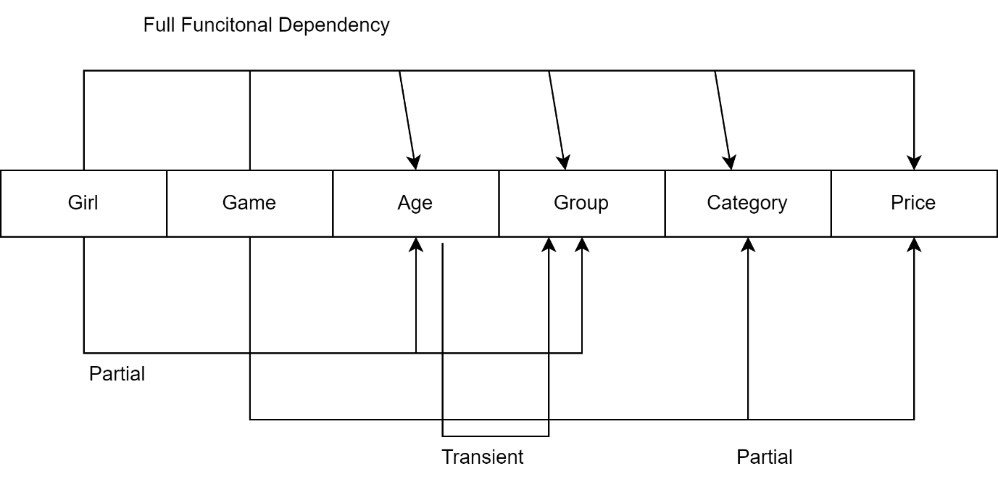Functional diagram:
5. Based on the functional dependency diagram above, I can conclude that the relation is in the 1NF form. This is true because every column has only a single value, indicating it is in at least 1NF form, however, the relation fails to comply with 2NF and therefore 3NF forms because of the partial and transient dependencies that exist within the relation.

6.

|  |  |
| --- | --- |
| **GIRL (PK)** | **GAME (PK)** |
| Charlotte | Mirror |
| Susan | Lipstick |
| Jane | Chess |
| Susan | Checkers |
| Susan | Mirror |
| Carrie | Lipstick |
| Jacqueline | Visual Basic |

|  |  |
| --- | --- |
| **GIRL (PK)** | **AGE (FK)** |
| Charlotte | 5 |
| Susan | 6 |
| Jane | 5 |
| Carrie | 6 |
| Jacqueline | 5 |

|  |  |
| --- | --- |
| **AGE (PK)** | **GROUP** |
| 5 | 5 year olds |
| 6 | 6 year olds |

|  |  |  |
| --- | --- | --- |
| **GAME (PK)** | **CATEGORY** | **PRICE** |
| Mirror | Makeup | 4.88 |
| Lipstick | Makeup | 5.95 |
| Checkers | Games | 5.95 |
| Chess | Games | 7.55 |
| Visual Basic | Prog. Languages | 199.99 |

There are 4 3NF relations needed to put the original relation into proper 3NF form.